**Test Results for Google Search engine.**

**TS_01:** Check whether the search box is clickable or not.

**Step 1:** Access the URL to access the google page.

**Step 2:** Click on search box option to check whether the textbox is clickable or not .

**Expected Result:** The Search box is clickable as expected.

**Actual Result:** Working as expected.

**TS_02:** Check if the google page is opening or not after entering https://www.google.com in the URL box or not.

Step 1: Open the new tab on device.

Step 2: Enter the below URL :

<https://www.google.com>

Expected Result: The URL is Accessible.

Actual Result: Working as expected.

**TS_03:** Check and hit the submit button without entering anything in the search field and clicking search; nothing should occur.

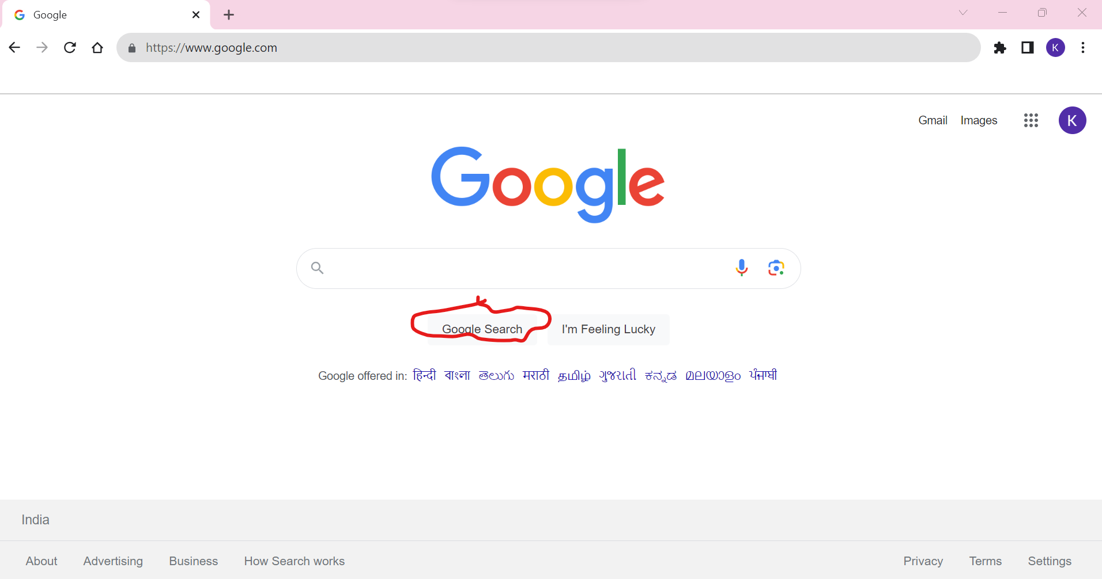

Expected Result: No action should be performed.

**TS_04:** Check if the user is searching by entering the special character like! @,#,$, etc., and hit the submit button; you should search with the alphanumeric values.

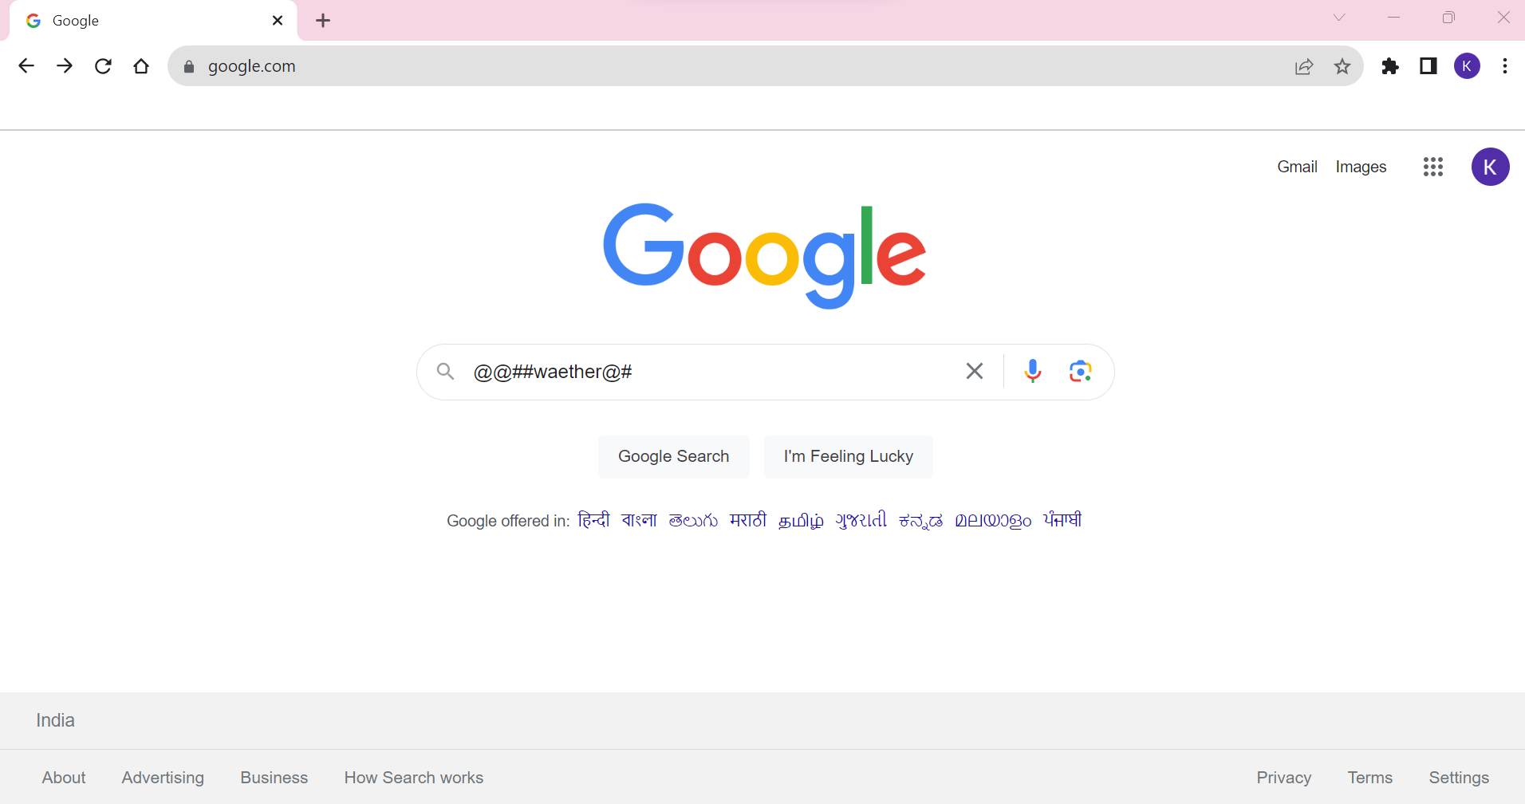

Expected Result : Results should be searched by using special characters .

**TS_05:** The “Did you mean” link should display if the person is searching with invalid input.

